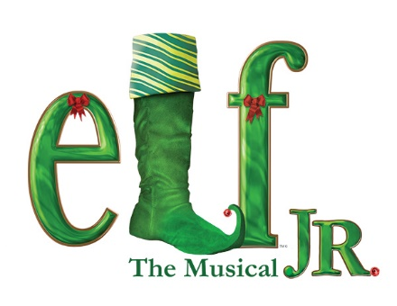
CAST LIST 2021
This is going to be a great show. If you do not see your name below please let us know, as it was an oversight. Email amitchell@caunj.org or jlebron@caunj.org so that it can be corrected. You have a week to tell us if you accept the part. If we don’t hear from you we will recast and that will be final-no reversals.

Our first table read will be on ZOOM this Tuesday the 20th from 6-7:30PM. We are so excited and hope you are too!!!! Meeting ID: 307 219 4733 Passcode: cauplay
SANTA - James Smith  Buddy the Elf - Tyler O’Neil  Charlie - Gerard Russomanno  Sawanda - Tonya Hopson  Business Woman - Carly Villanueva  Jogger - Aiden Dolan  New Yorker - Michelle Rosenkrans  Smart cracking New Yorker - Scott Birnbaum  Mr Greenway - Ernie Small  Matthews - James Beekman  Charlotte Dennon, news reporter - Shannen Jones  Darlene Lambert - Kim Barry  Emma Von Brocklin - Cassandra Smith  Mother - Dianna Simms  Chadwick - DJ Rivera  Harvey – Anthony Tamburello | Sam - Ryan Durkin  Walter Hobbs - Adam Fleissner  Deb - Melody Lucas  Emily Hobb - Gaby Thomas  Michael Hobb - James McArthur  Security Guards - Dipen Trivedi, John Dresher  Macys Perfume lady - Brianna Tamburello  Macys Manager- Michael Ehringer  Jovie - Zoe Rivera  Santa’s helper - Alexis Lorenc  Fake Santa - Michael Perrone  Child on his lap - Jackson Modero  Policemen - Maurice Stephens, Christopher Dione  Sarah - Megan Stephans  Snowflake Ballet - Cassidy Deegan
Children on line  Scarlette Storey, Emmayah Storey,  Bella Jacks, Mackenzie Modero, Daniel Shepard  Parents  Jessie Gaeta, Josh Lucus, Giovani Mancini, Taylor LaFalse, Sunnah Bial Shakir | Workshop Elves  Andrew Berry, Terrell Ross, Dianna Simms, Meckenzie Modero, Jackson Modero, Bella Jacks, Kim Berry, John Drescher, Jesse Gaeta, Sara Law, Cassidy Deegan, Scarlette Storey, Emmayah Storey, Welena Noel,  Allison Sosnnewski
Street Carolers  James Beckham, Ryan Durkin, Kim Berry, DJ Rivera, Mackenzie Modero, Cassidy Deegan, Faith Greene, Beth Tooker, Sara Law, Isa Jamal, Michelle Rosenkrans, Gerard Russomanno, Scott Birnbaum | Macys workers and NY residents  Benjamin Stere, Allison Sosnewski, Caila Breslin,Kimberly Rosato,Laron Murray, Jose Tavaras, Joe Nitti, Christine Capio, Dipen Trivedi, Maurice Stephens,  Alexis Lorenc, Cassandra Smith, Dianna Simms, Terrell Ross, Shennen Jones, Anthony Tamburello, Clarence Kenner

As you can see there are many important ensemble parts. I have not counted the people who spot Santa, the news reporter crowd, etc. They will be distributed as we go. So let’s all get in the holiday spirit and begin our journey.

Just Believe!

